“Antique Lace Vase”
Earthenware Clay, Antique Lace
Minimum Bid: $50.00
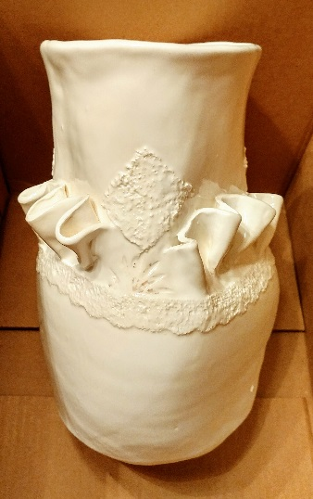
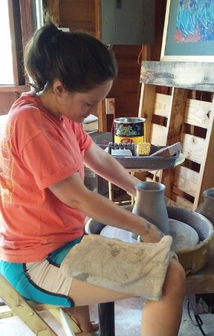
India Maureen Cox is an art educator at Braddock Elementary School. She graduated from Maryland Institute College of Art and has experience teaching art to students from pre-school through 12th grade. This is her second year teaching art at Braddock Elementary and she loves building relationships with the wonderful staff and students.
Outside of school, India creates ceramic artwork largely inspired by her Southern heritage. Most of her ceramic works are wheel-thrown and altered in her home studio. Besides wheel-thrown pottery, India also enjoys oil painting, repurposing antique jewelry, floral arranging, felting and other fiber arts. You can see more of her work at http://icox012.wixsite.com/indiamaureencox or http://portfolios.mica.edu/IndiaMaureenCox .

