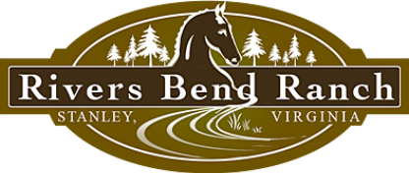
Western Weekend Getaway
Rivers Bend Ranch; 2 hours from DC area
2 nights; Sleeps 6-8
Value: $ 650

Off-Season Dates Available-Spring/Summer 2017
http://www.riversbendranch.com/the-lodge.html

Rivers Bend Ranch, a guest ranch and event venue situated on nearly 300 beautiful acres nestled between the Blue Ridge Mountains and the George Washington National Forest. With a half-mile of shoreline on the Shenandoah River, and over 20 bedrooms on-site, RBR offers the perfect setting for family vacations and reunions, weddings, corporate retreats, or just a quiet weekend getaway.
On the ranch guests can enjoy fishing, birding, and walking trails, as well as lawn games and our indoor game room. Trail rides along our piece of the Shenandoah's South Fork are available to guests and the general public, and can accommodate any riding ability.
Join us for a weekend getaway in our beautiful “Lodge.” The largest of our cabin suites, the Lodge has three bedrooms, a living room with flat-screen cable TV, a full kitchen, w&d, and two full baths with a jacuzzi in the master. Comfortably sleeps 6, or up to 8 using fold-out sofa. Rocking chairs on the covered, wrap-around porch are the perfect place to enjoy a cup of coffee and incredible views of the surrounding mountains!

